## Settings Manager (xfce4-settings)测试（6）

测试内容：MIME Type Editor, Session and Startup, Settings Editor

环境：QEMU6.2.0、openEuler20.0.3、xfce4、Image-mouse-kbd

## MIME Type Editor

1、打开Setting界面，选择Default Application，选择Others选项：

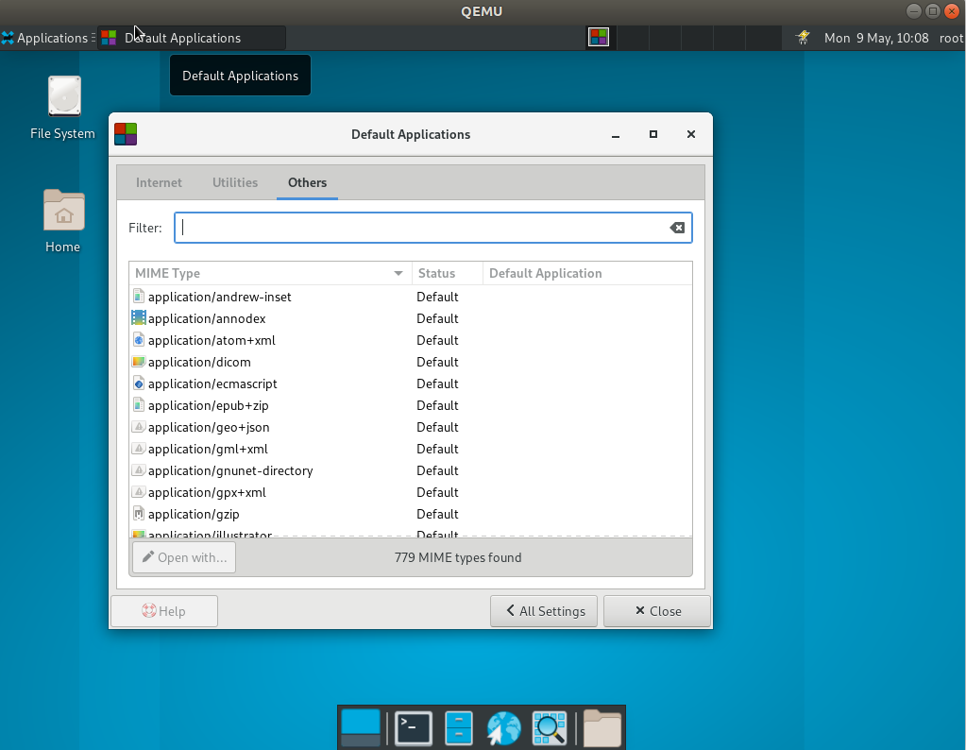

选中一项，点击Open With按钮，可以设置使用什么应用打开：

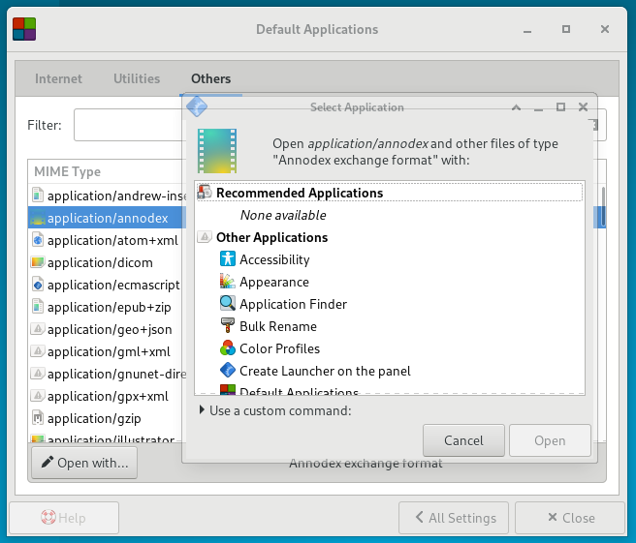

Internet界面：可以设置默认浏览器以及邮箱阅读器

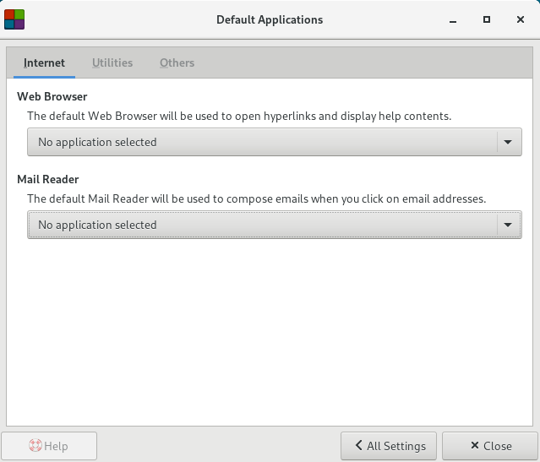

Utilties界面：设置默认文件管理器应用以及终端应用：

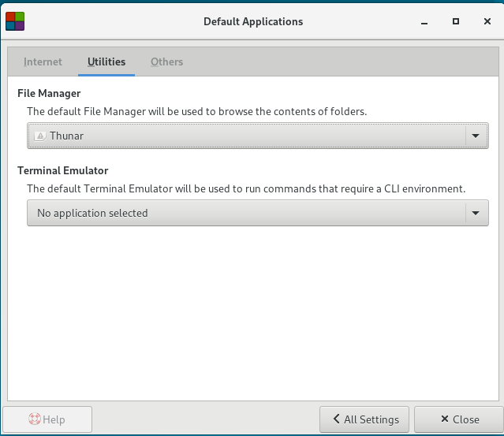

File Manager’设置使用Thunar打开。

**！！！！！！！测试时尝试安装xfce4-terminal，安装后xfce4无法启动，卸载后问题依然存在。错误报告贴在文档末**

## Session and Startup

1. Setting->Session and Startup

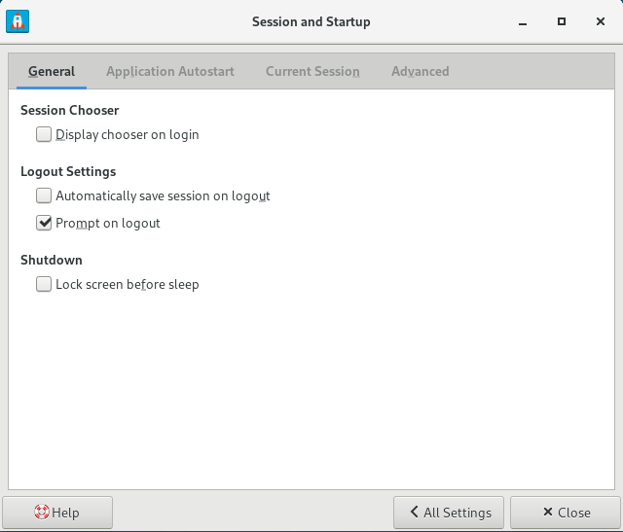

Display chooser on Login: 如果勾选，会话管理器将要求您在每次登录到 Xfce 时选择一个会话

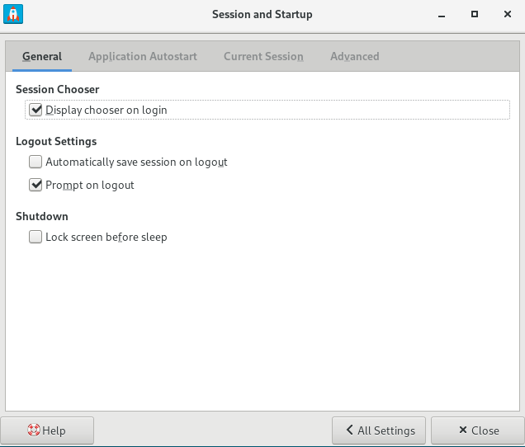

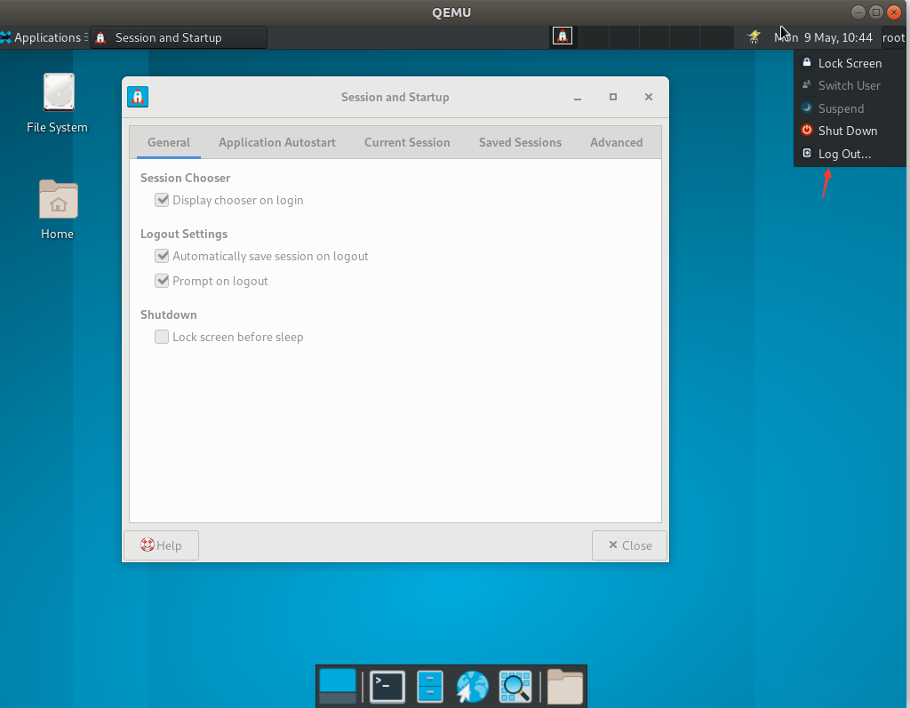 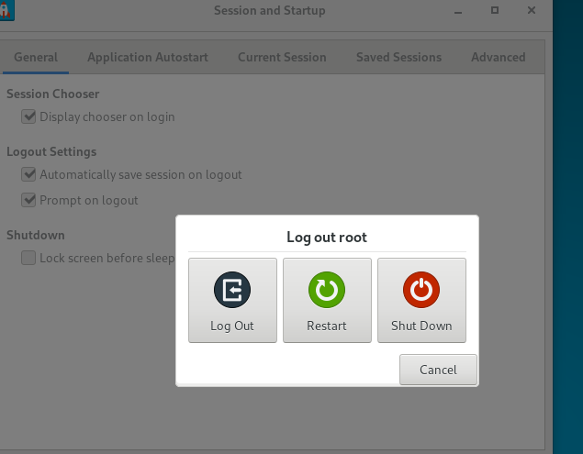

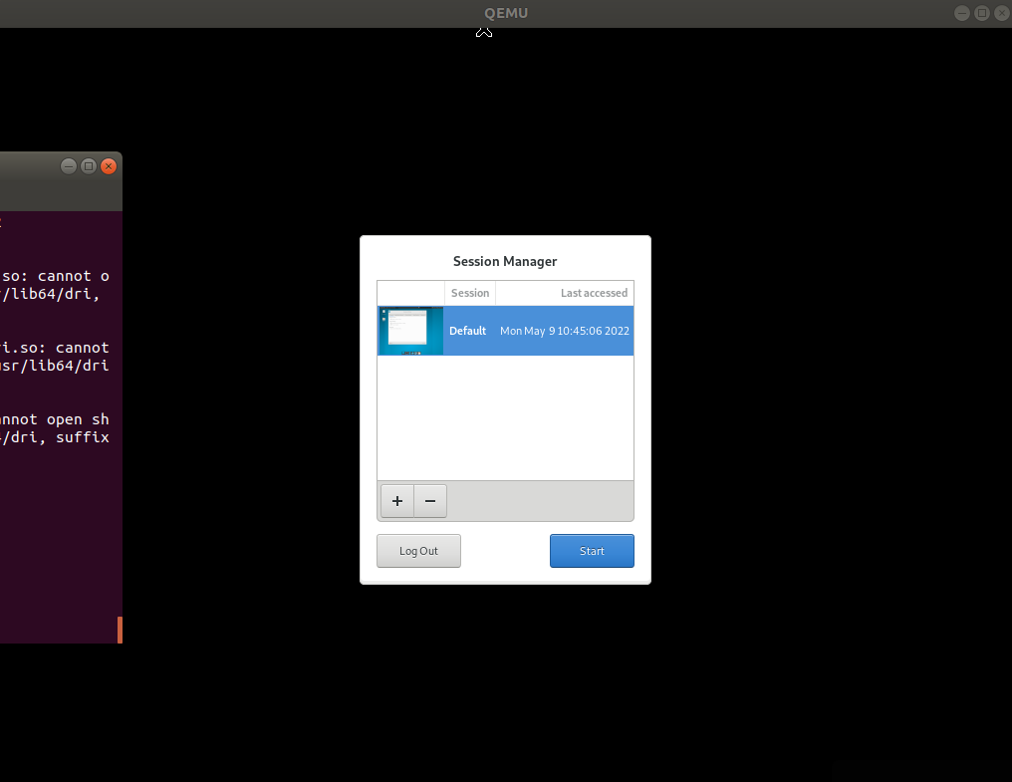

2、Automatically save session on logout：此选项指示会话管理器在注销时自动保存当前会话。如果您没有选择此选项，则会提示您是否要在每次注销时保存当前会话。

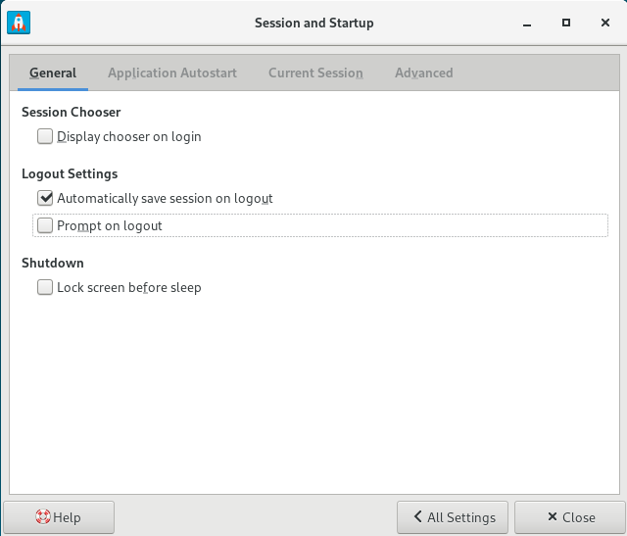

1. Prompt on logout：关掉后，注销时不会询问
2. Lock screen before sleep：睡眠时锁屏
3. Application Autostart：设置开机自启应用

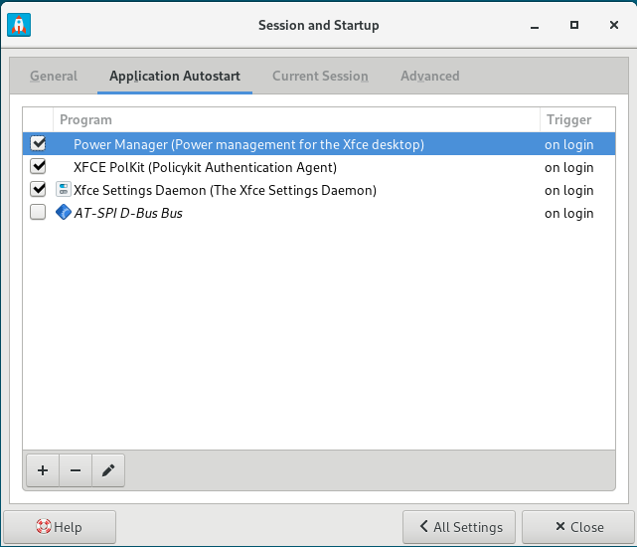 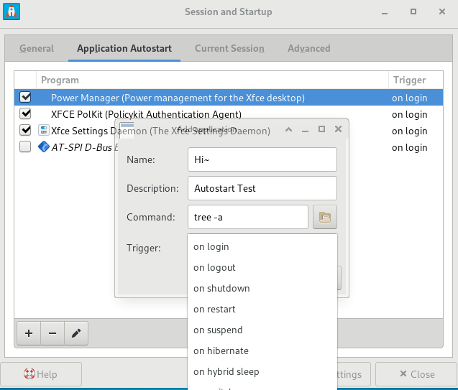

左下角：添加、删除、编辑

6、Current Session：应用管理器

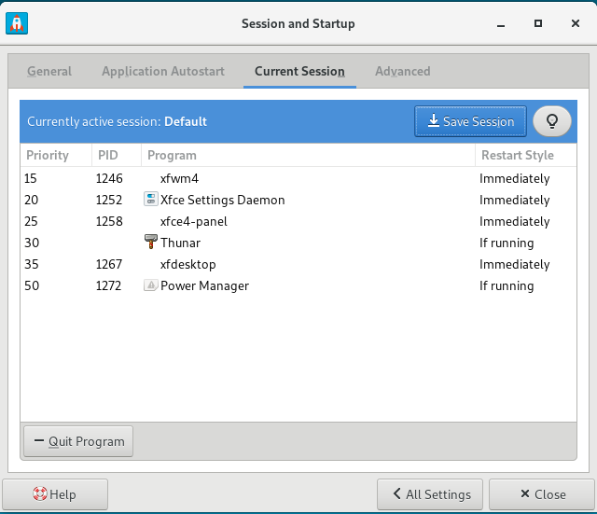

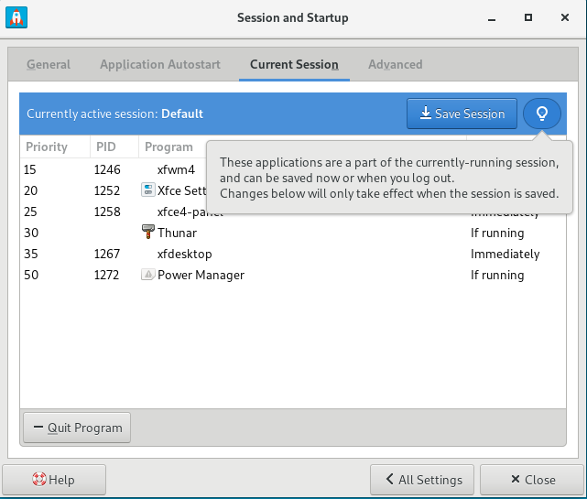

点击Save Session可以保存当前会话窗口

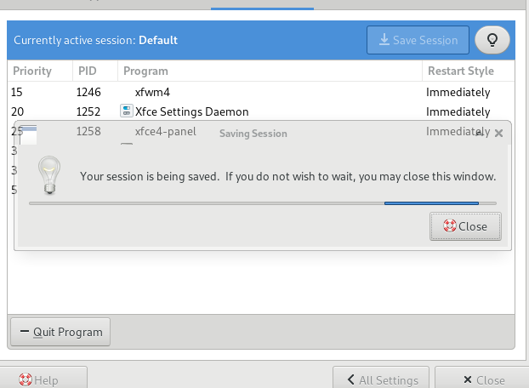

选中一条应用，点击Qui Program可以强制结束一个应用

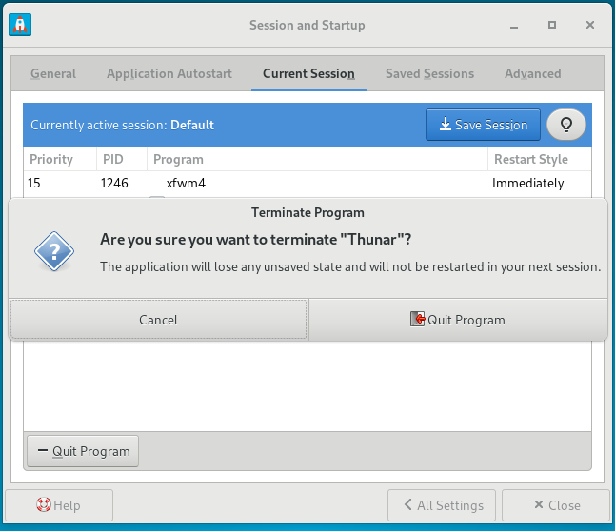

1. Saved Session中可以看到刚刚保存的Session：

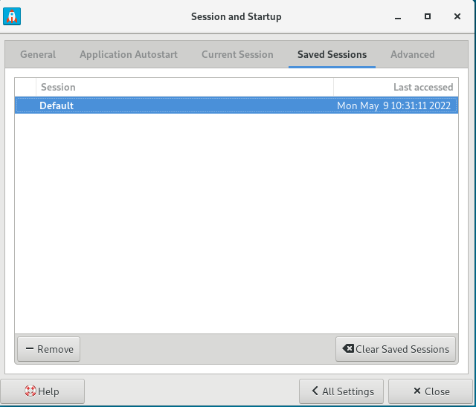

点击Clear 可以删除所有保存的Session

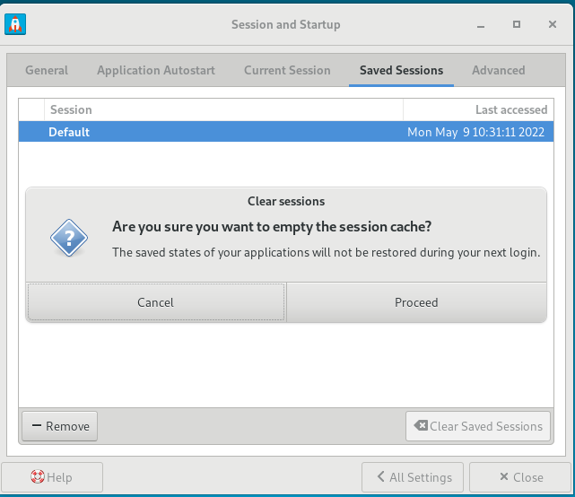

1. Advanced：
   1. **Launch GNOME services on startup：开机自启GNOME程序**
   2. **Launch KDE services on startup：开机启动KDE服务**
   3. **Manage remote applications：打开后允许会话管理远程主机**

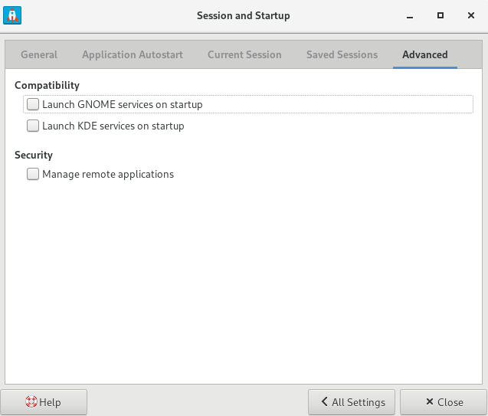 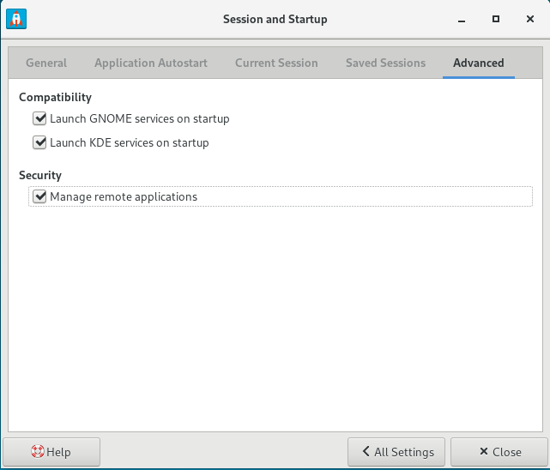

## Settings Editor

1. Setting -> Setting Editor:

图形化的编辑Xfconf的工具

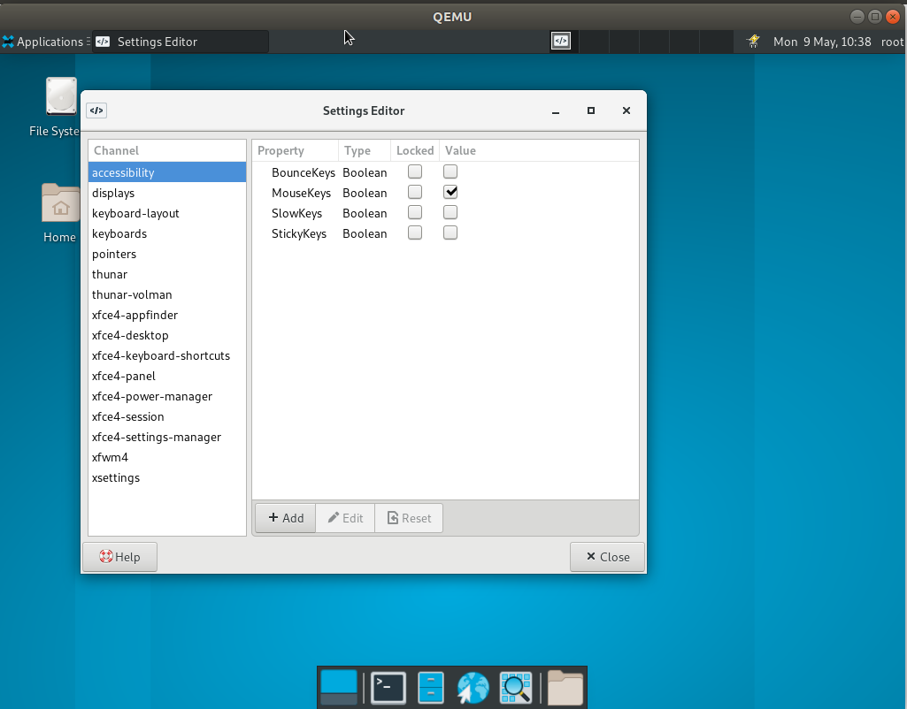

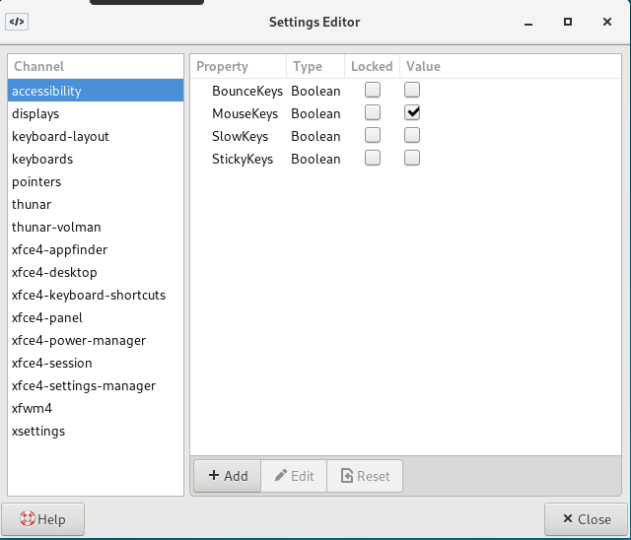 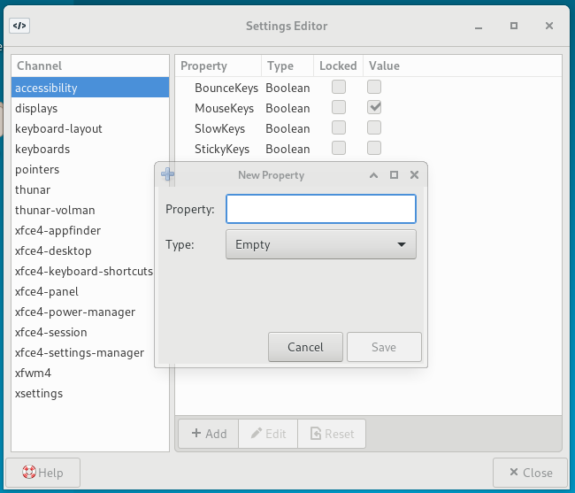 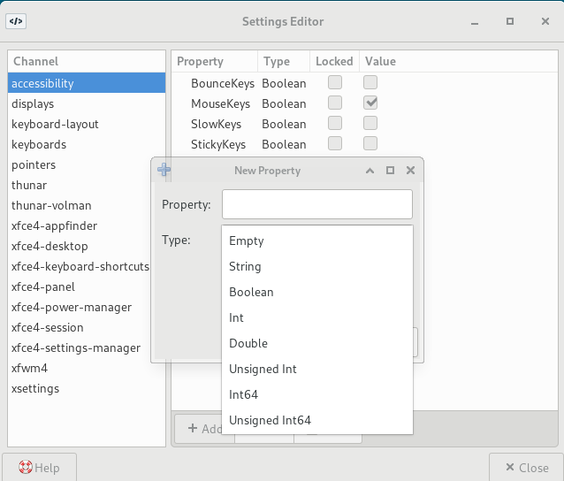

**安装Xfce4-terminal后，系统无法进入：**

**安装过程:  
Upgraded:**

**gtk3-3.24.30-5.oe1.riscv64**

**Installed:**

**xfce4-terminal-0.8.10-1.oe1.riscv64**

**dconf-0.38.0-1.oe1.riscv64**

**dejavu-fonts-2.37-1.oe1.noarch**

**gtk-update-icon-cache-3.24.30-5.oe1.riscv64**

**vte291-0.62.3-1.oe1.riscv64**

**xfce启动报错：**

**[root@openEuler-RISCV-rare ~]# startxfce4**

**/usr/bin/startxfce4: Starting X server**

**X.Org X Server 1.20.11**

**X Protocol Version 11, Revision 0**

**Build Operating System: oe-RISCV-worker25 5.10-3.oe1.riscv64**

**Current Operating System: Linux openEuler-RISCV-rare 5.10.0 #1 SMP Sat Apr 2 15:21:07 CST 2022 riscv64**

**Kernel command line: loglevel=3 swiotlb=1 console=ttyS0 rw root=/dev/vda1**

**Build Date: 23 April 2022 09:52:30AM**

**Build ID: xorg-x11-server 1.20.11-4.oe1**

**Current version of pixman: 0.38.0**

**Before reporting problems, check http://wiki.x.org**

**to make sure that you have the latest version.**

**Markers: (--) probed, (**) from config file, (==) default setting,**

**(++) from command line, (!!) notice, (II) informational,**

**(WW) warning, (EE) error, (NI) not implemented, (??) unknown.**

**(==) Log file: "/var/log/Xorg.0.log", Time: Mon May 9 10:51:32 2022**

**(==) Using system config directory "/usr/share/X11/xorg.conf.d"**

**pci id for fd 11: 1234:1111, driver (null)**

**MESA-LOADER: failed to open bochs-drm: /usr/lib64/dri/bochs-drm_dri.so: cannot open shared object file: No such file or directory (search paths /usr/lib64/dri, suffix _dri)**

**failed to load driver: bochs-drm**

**MESA-LOADER: failed to open kms_swrast: /usr/lib64/dri/kms_swrast_dri.so: cannot open shared object file: No such file or directory (search paths /usr/lib64/dri, suffix _dri)**

**failed to load driver: kms_swrast**

**MESA-LOADER: failed to open swrast: /usr/lib64/dri/swrast_dri.so: cannot open shared object file: No such file or directory (search paths /usr/lib64/dri, suffix _dri)**

**failed to load swrast driver**

**couldn't get display device**

**(II) modeset(0): Initializing kms color map for depth 24, 8 bpc.**

**The XKEYBOARD keymap compiler (xkbcomp) reports:**

**> Internal error: Could not resolve keysym XF86MonBrightnessCycle**

**> Internal error: Could not resolve keysym XF86RotationLockToggle**

**> Internal error: Could not resolve keysym XF86FullScreen**

**Errors from xkbcomp are not fatal to the X server**

**<stdin>:0: warning: Unknown encoding: C.UTF-8**

**xfce4-session: symbol lookup error: /usr/lib64/libgtk-3.so.0: undefined symbol: atk_plug_set_child**

**xinit: connection to X server lost**

**waiting for X server to shut down (II) Server terminated successfully (0). Closing log file.**

**怀疑是安装的时候升级了gtk3到最新版本导致的。**